Glassdoor – Dimensional Modelling

SQL Server Express Table Screenshots

Divya Jayaprakash – dxj160830

Dimension Tables:

1. Dim_Time_Divya_J

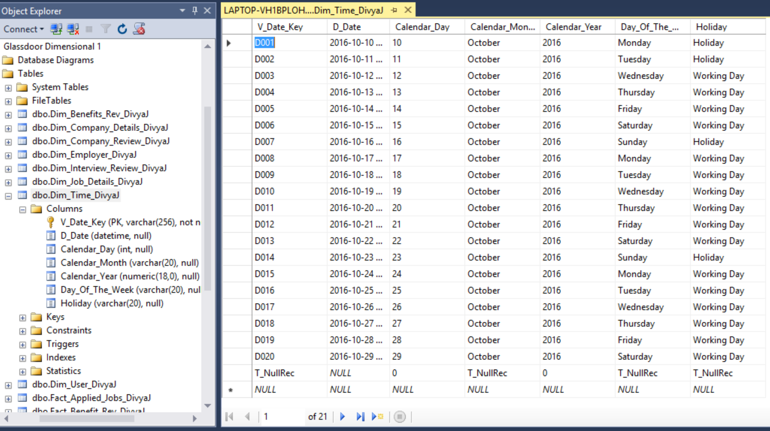

1. Dim_User_DivyaJ

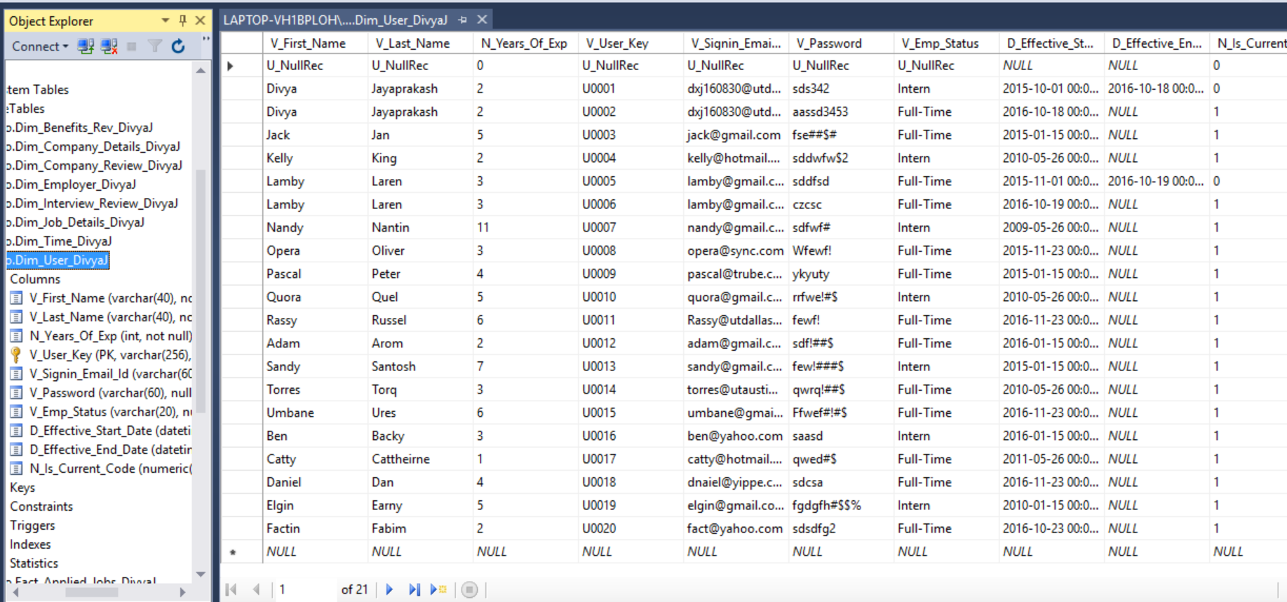

1. Dim_Employer_DivyaJ

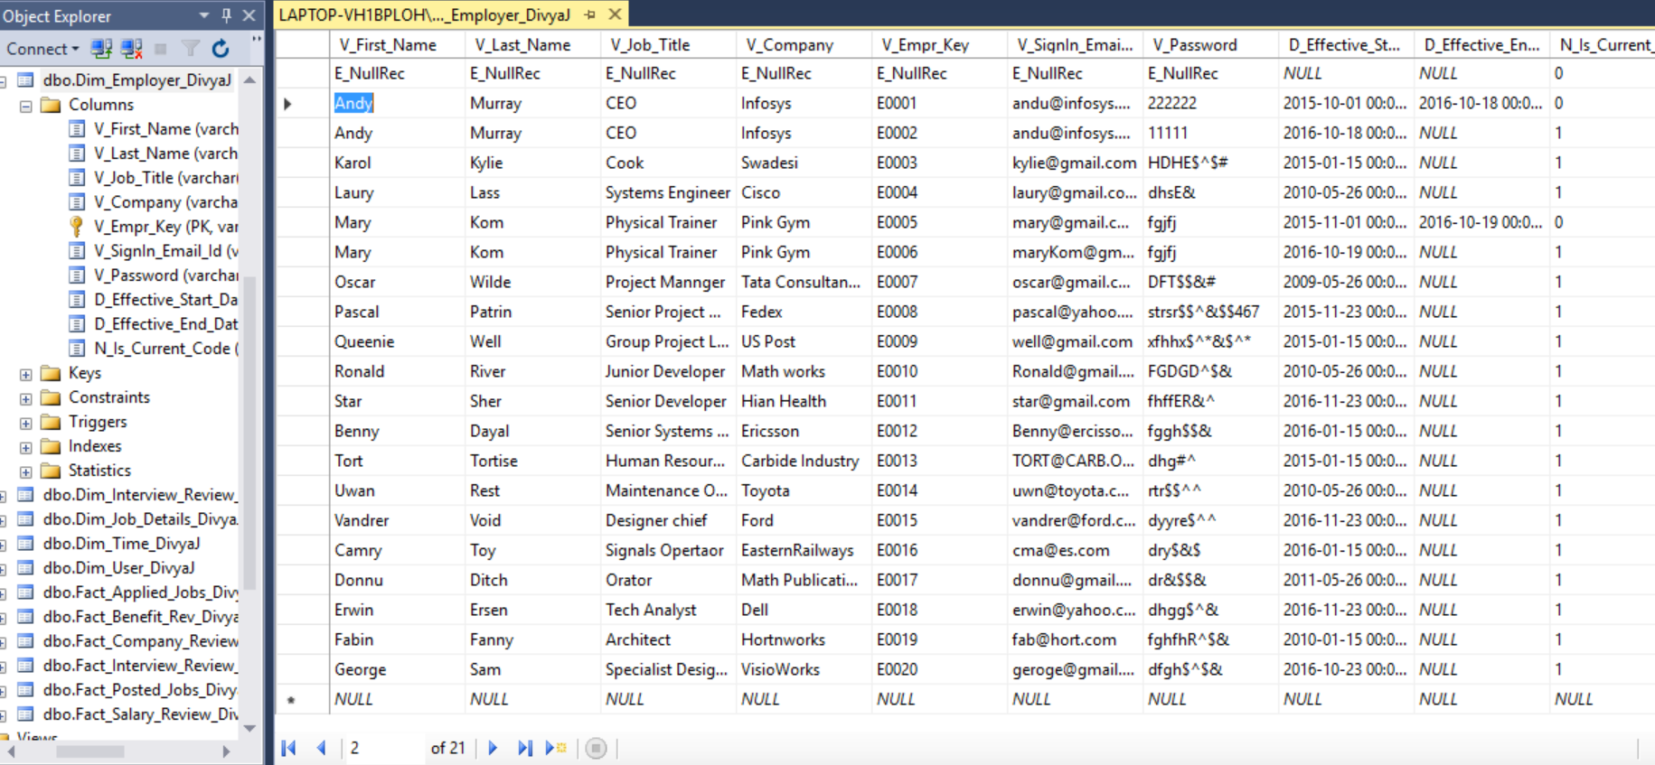

1. Dim_Company_Details_DivyaJ

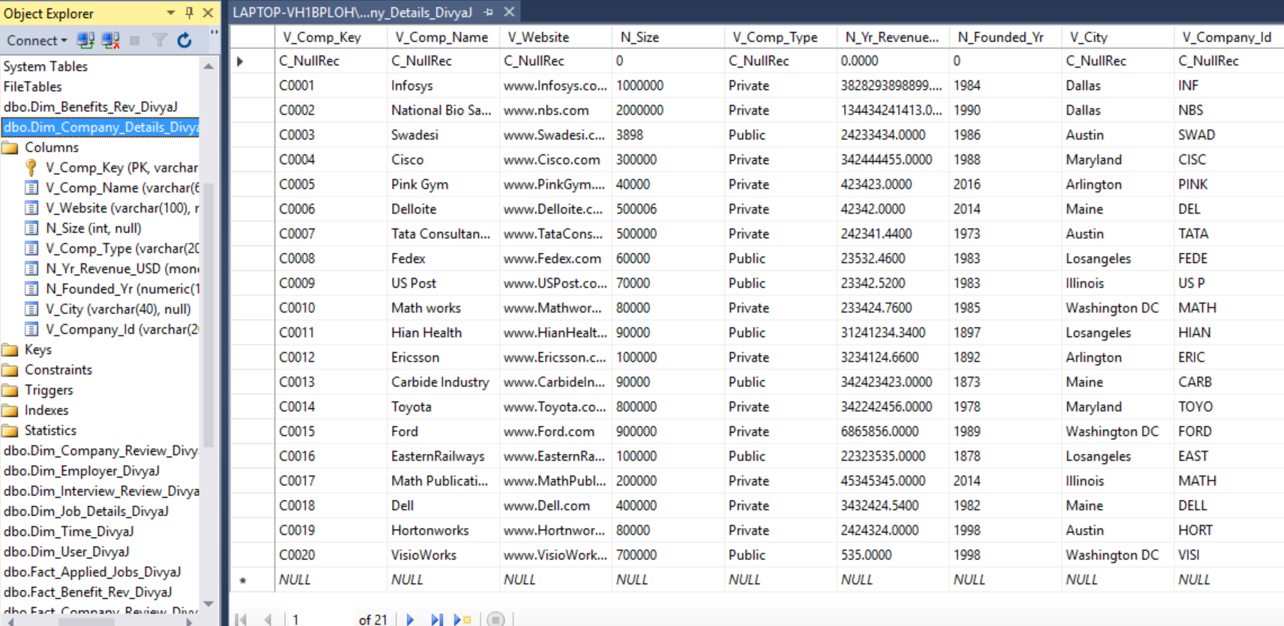

1. Dim_Job_Details_DivyaJ

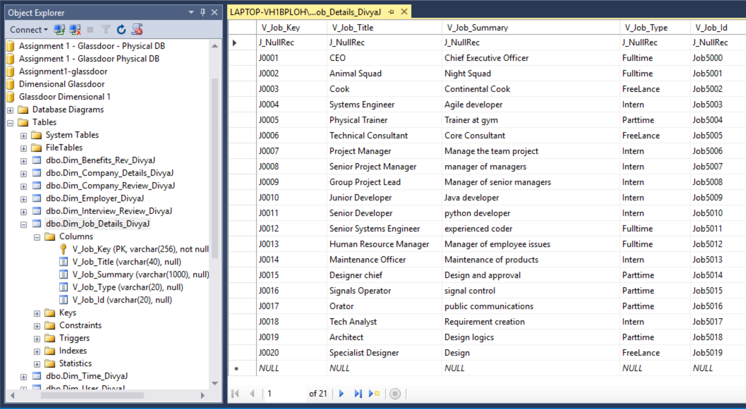

1. Dim_Company_Review_DivyaJ

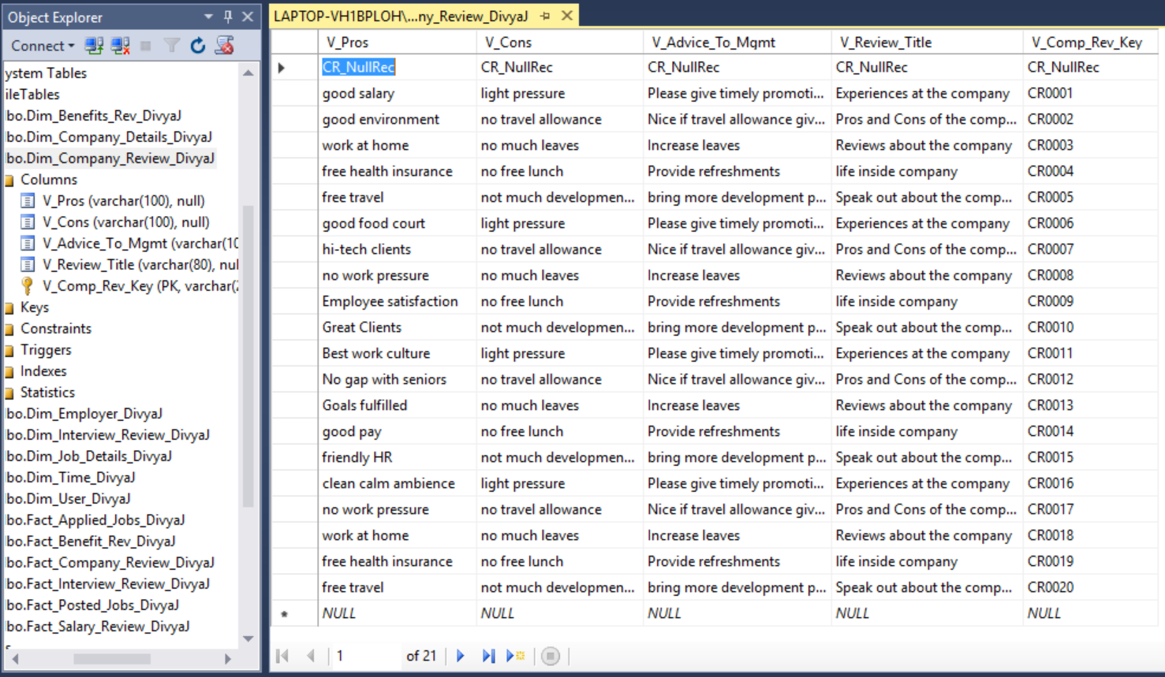

1. Dim_Benefits_Rev_DivyaJ

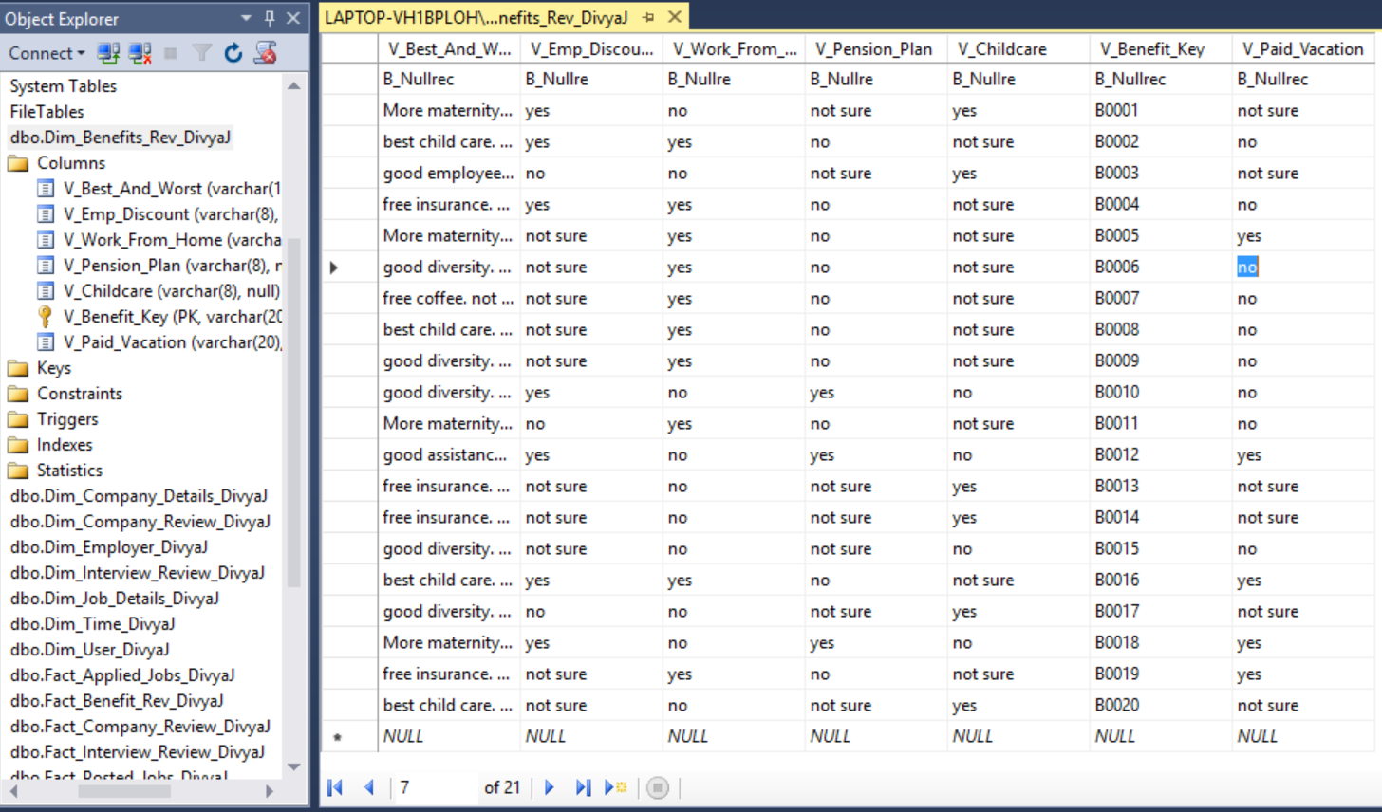

1. Dim_Interview_Review_DivyaJ

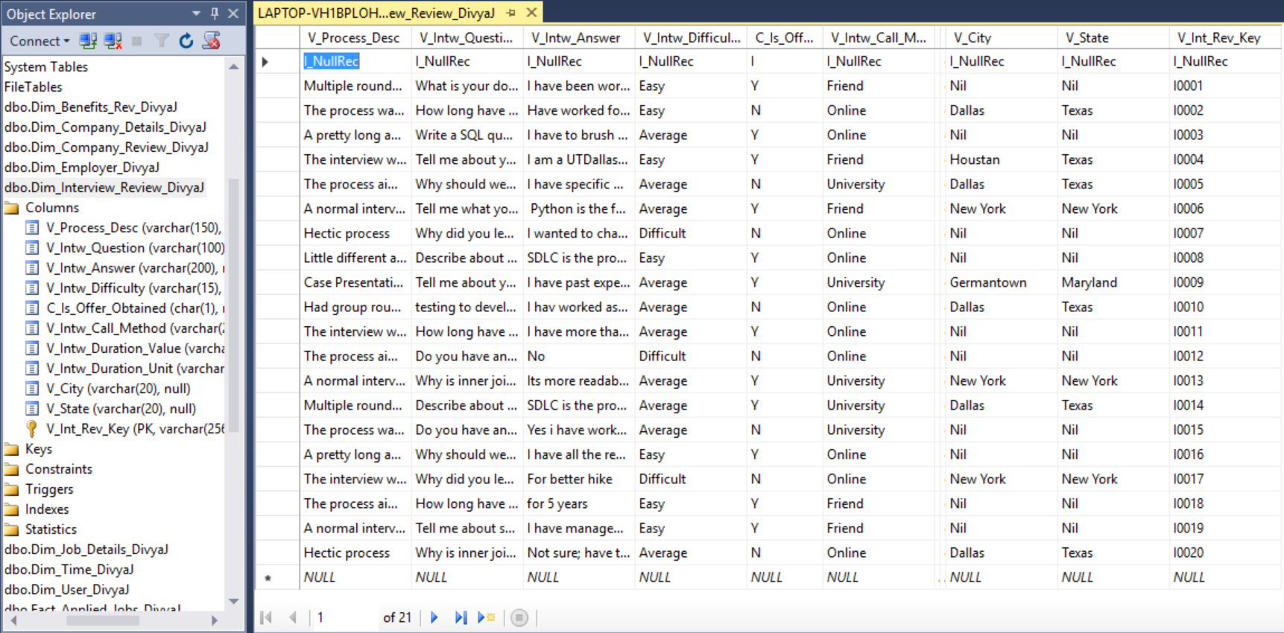

Fact Tables:

1. Fact_Posted_Jobs_DivyaJ

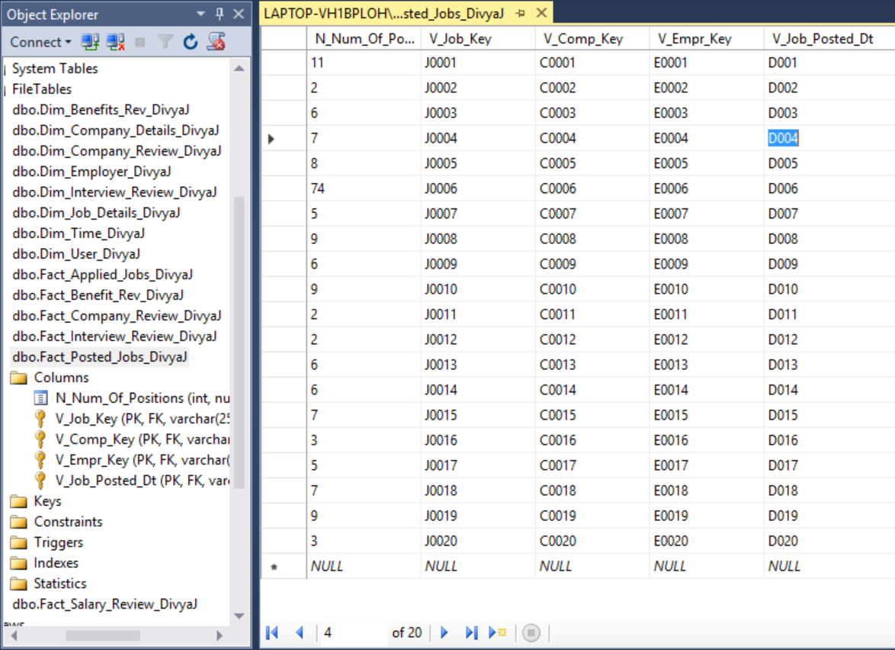

1. Fact_Applied_Jobs_DivyaJ

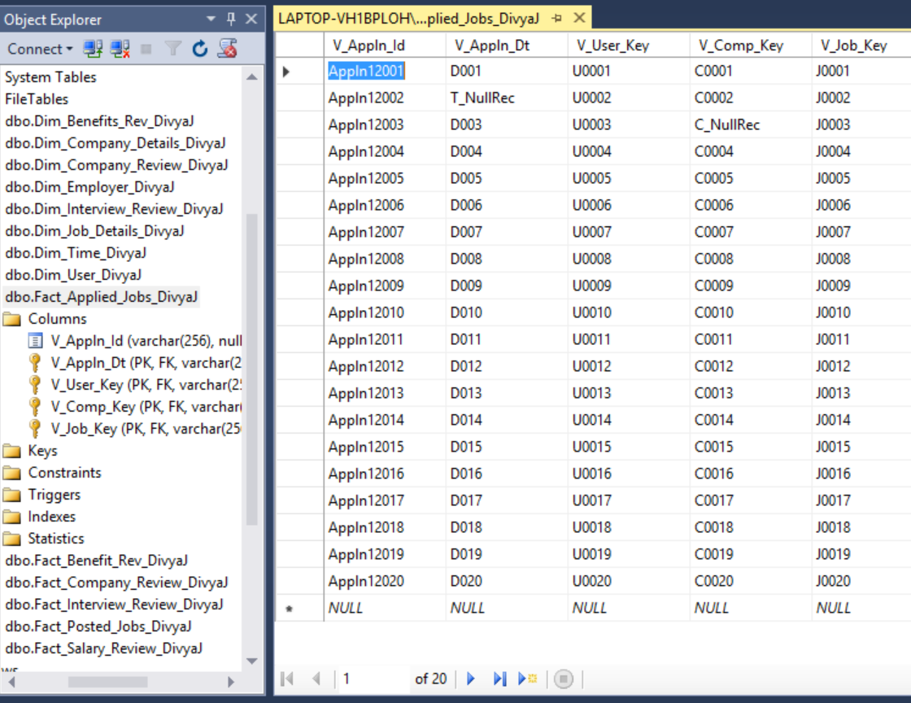

1. Fact_Company_Review_DivyaJ

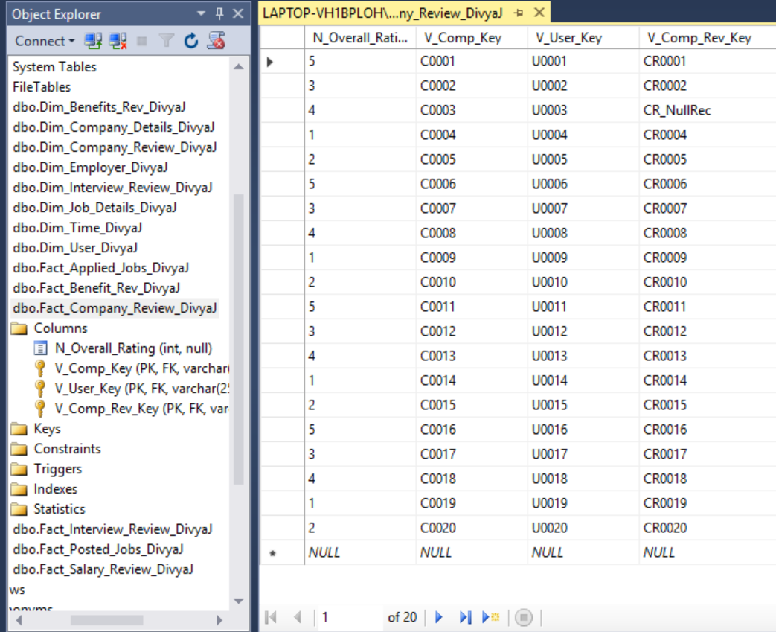

1. Fact_Benefit_Rev_DivyaJ

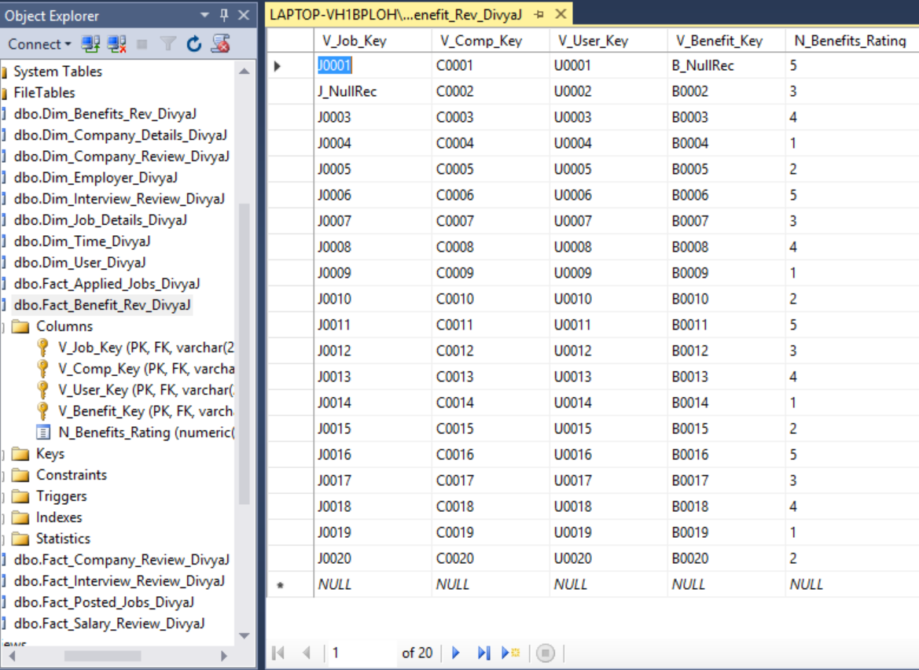

1. Fact_Salary_Review_DivyaJ

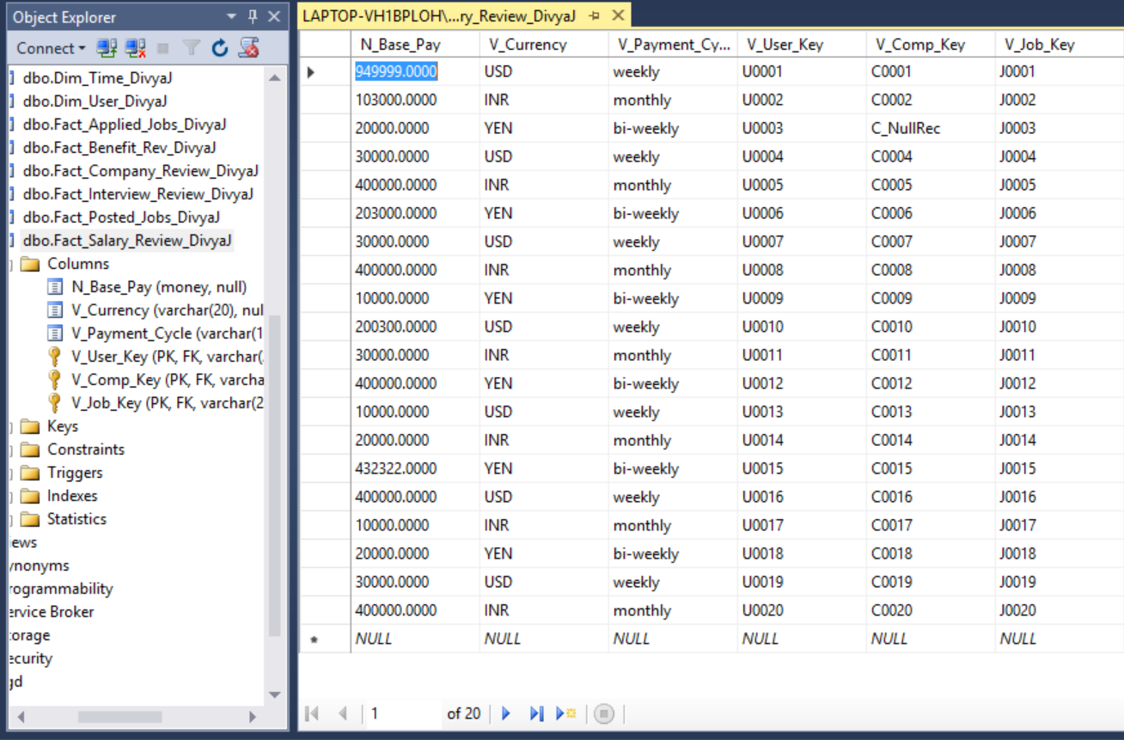

1. Fact_Interview_Review_DivyaJ

